**Hexadecimal**

**How to switch between systems ?????**

1. Binary System
2. Decimal System
3. Une image contenant table

   Description générée automatiquementHexadecimal

**Binary to Decimal**

So Here power 2 is used to convert from binary system to Decimal system , By example :

We will convert (1001)2  to decimal :

**23**

**22**

**21**

**20**

0

0

1

1

So , the result is 1 *1 + 1*8 = 9

To avoid writen power : 1 2 4 8 16 32 64 128 256 512 1024 ….

Mutiply by 2 . so the fist number * 1 and the second * 2

**The second example : convert (11011)2  to decimal**

So based on our list : note we don’t count 0 before it’s like an closed transistor

**So for slove this we need paper (ehhhh)**



So Resutl is : 1+2+8+16 = 27 🡺 **(11011)2  = (27)10**

Other example : **convert (110101)2  to decimal**



So Result is = 1+4+16+32=53 🡺 **(110101)2  = (53)10**

Other example : **convert (1101001)2  to decimal**

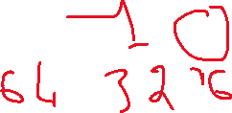

So Result is = 1+8+32+64=53 🡺 **(110101)2  = (105)10**

**Decimal to Binary**

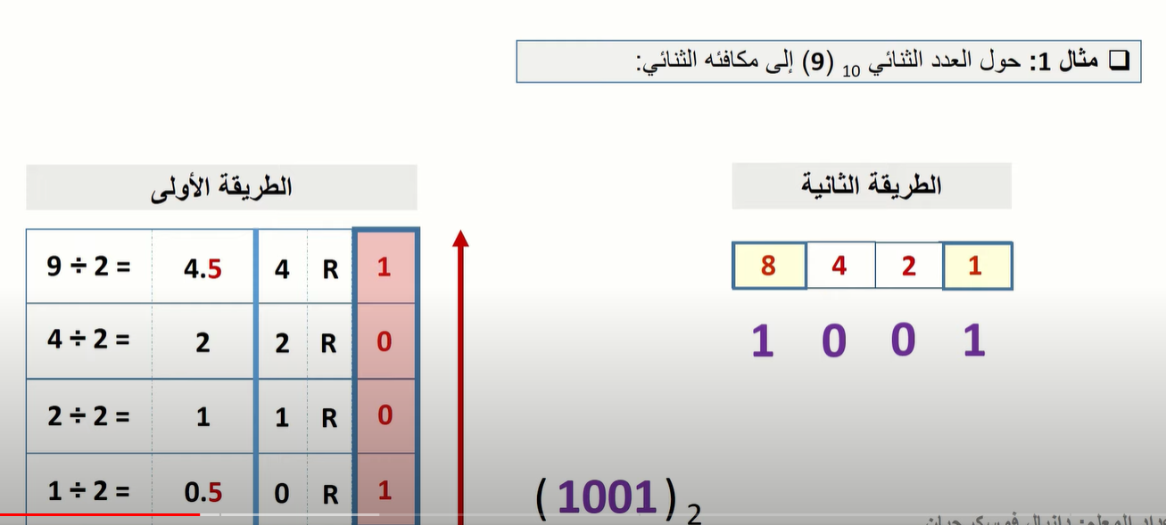**Here we have two methods :**

**First method note : we take the number and we devide it into two**

**We take the result int without digit , and in the digit you will get 0.5 or 0 ( if you devide even number and 0.5 if you devide odd number)**

**So we multiply the digit *2 so we will get 1 or 0 ( 0 if no digit and 1 if there is 0.5 in digits ) , when we arrive at 0 we stopp , and the binary is the rest of this process but we take it from bottom to top as the image show .**

Second method : First thing we put our list and the last number in this list should be small or equal the number that we want to convert , then we ask us which are the numbers that if we groupping them we will get our number (by the way the last number is always choosed ).

example : **convert (25)10  to Binary**

The first method :



The second Method :

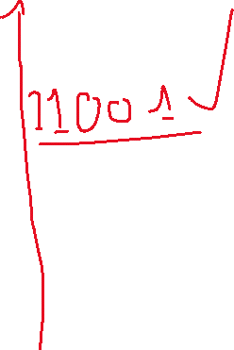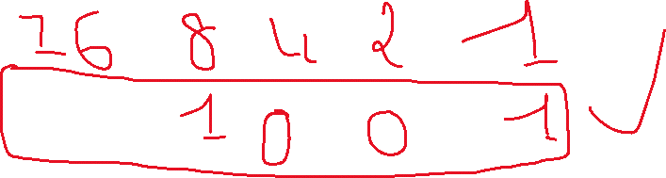

**(25)10  = (11001)2**

Other example : **convert (61)2  to Binary**

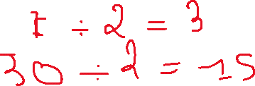

The second Method

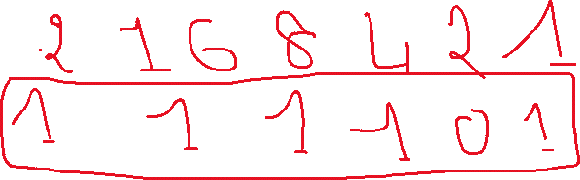

**(61)10  = (111101)2**

Other example : **convert (54)2  to Binary**

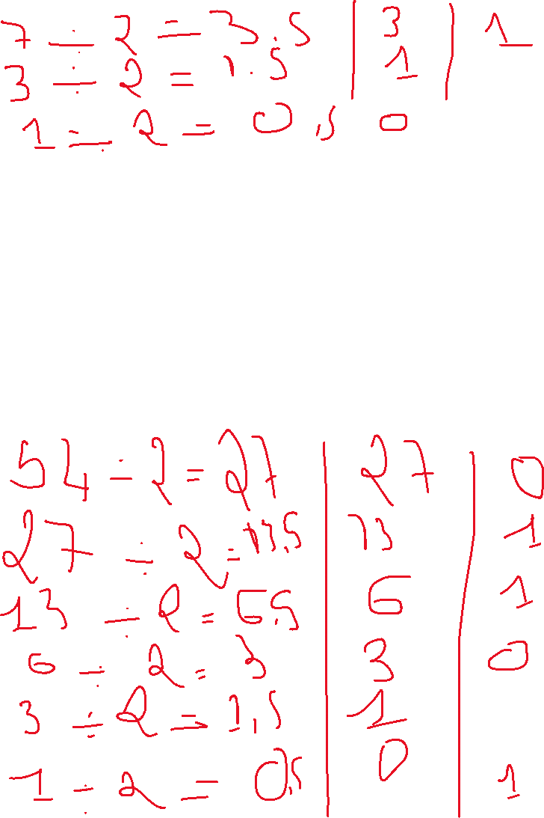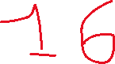

**(54)10  = (110110)2**

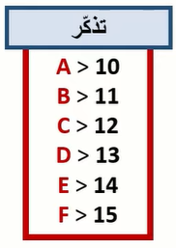**Hexadecimal to decimal**

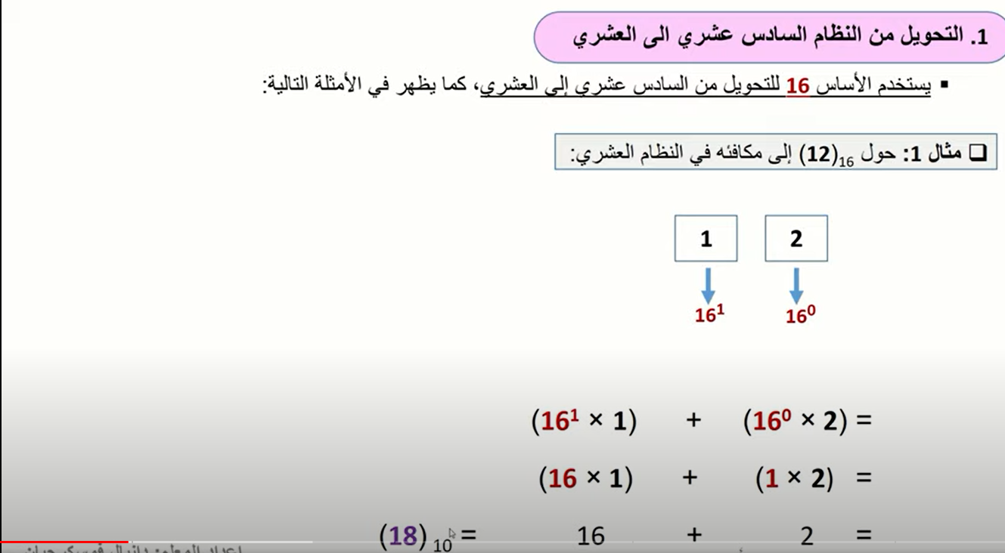

Note : make in mind that if you want to convert a value by any system to a decimal value you have to use the base of the original value system : binary to decimal 🡺 2 / hexadicimal to decimal 🡺16

example : **convert (3A7)16  to Decimal**

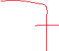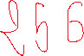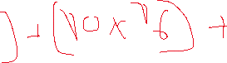

**(3A7)16  = (935)10**

example : **convert (E29B)16  to Decimal**

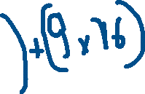

**(E29B)16  = (5811)10**

example : **convert (1F6D5)16  to Decimal**

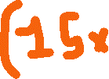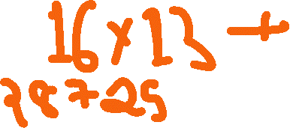

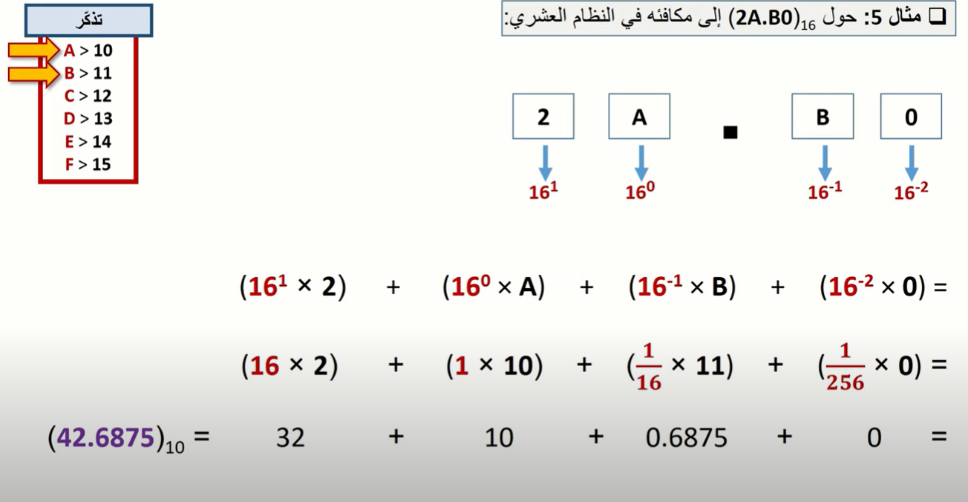**(1F6D5)16  = (128725)10**

**Decimal to Hexadecimal**

**Note : make in mind , if want to convert a decimal value to an other sytem value . always we use the base of the sytem wich we want to convert to , by examle decimal to binary we use 2 in division process and in octal we use 8 so in hexadicimal we should use 16**

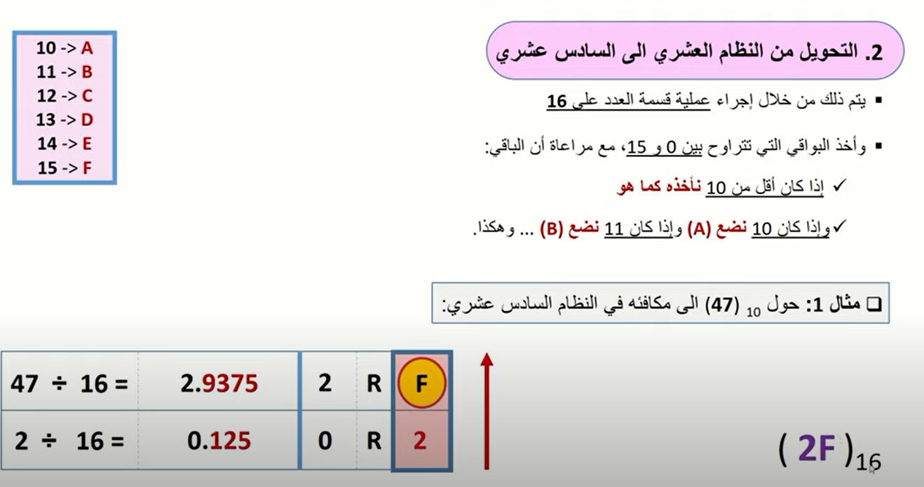

example : **convert (199)10  to Hexadecimal**



**(199)16  = (C7)16**

example : **convert (512)10  to Hexadecimal**



**(199)16  = (C7)16**

example : **convert (420)10  to Hexadecimal**



**(420)16  = (1A4)16**

example : **convert (14259)10  to Hexadecimal**

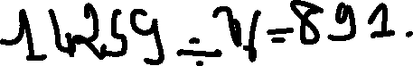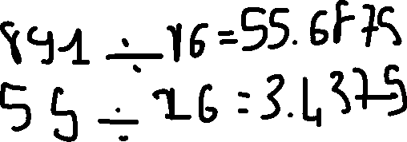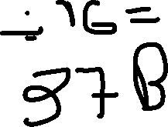

**(14259)10  = (37B3)16**

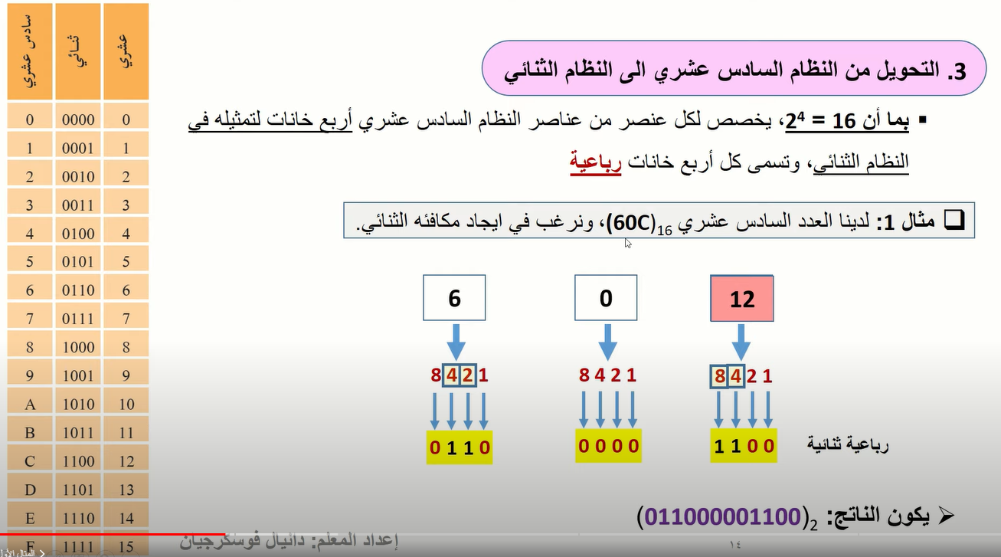**Hexadecimal to Binary**

example : **convert (AB29)16  to Binary**



**(AB29)16  = (1010101100101001)2**

example : **convert (54FE)16  to Binary**



**(54FE)16  = (0101010011111110)2**

example : **convert (E7D6)16  to Binary**



**(E7D6)16  = (1110011111010110)2**

**Binary to Hexadecimal**

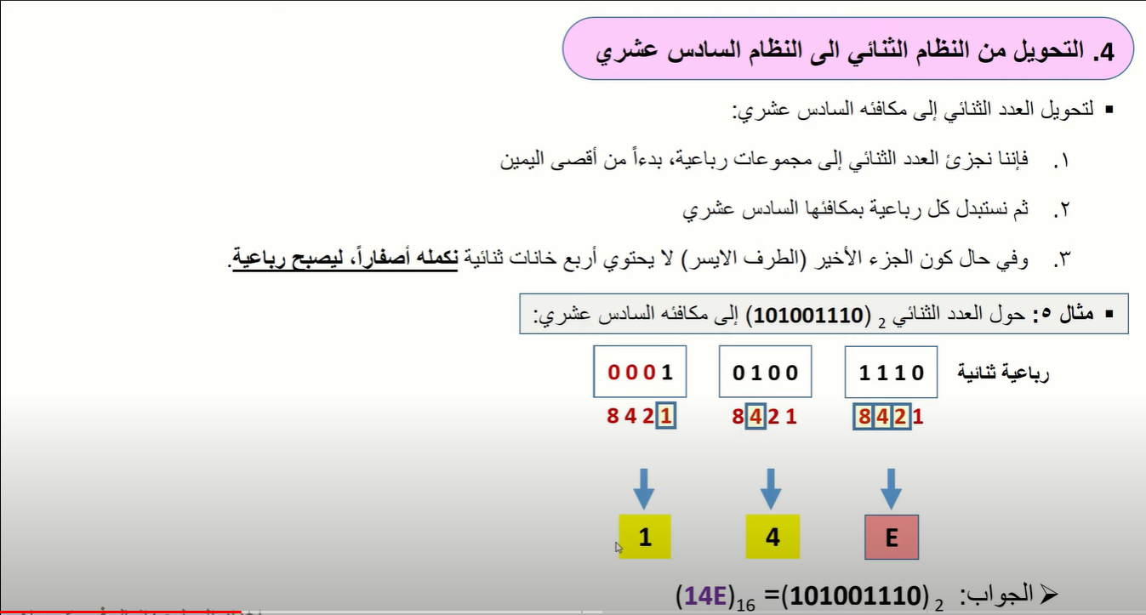

example : **convert (11011001011010)16  to Binary**

**0011 0110 0101 1010**



**(11011001011010)2  = (365A)16**

example : **convert (11111011110010010)16  to Binary**

**0001 1111 1001 0010**



**(11111011110010010)2  = (1F92)16**

example : **convert (1001111110011011000001)16  to Binary**

**0010 0111 1110 0110 1100 0001**



**(1001111110011011000001)2  = (27E6C1)16**

**Hexadecimal uses : Memory made up of several byte , as we say the last if you want to save data type char so it will be saved in one byte and if you want to save data type int so it will be saved in 4 byte ,**

**The imoportant that you want to know that each byte has an adress for that you can arrive to it after that and the address is writed by hexadecimal system , but for make diffrence between decimal and hexadecimal before each hexadecimal value we write ‘0x’**

**Example : 0x0004**

**And the second used is RGB because hexadecimal with decimal 255 take 3 places but hexadicimal take only two FF**

